ACADEMIA CONNECT PROJECT REPORT

Project Title: Academia Connect Student Analytics Dashboard
Developer: Yerram Naga Shasanka
Tech Stack Components: Python, FastAPI, SQLite, SQLAlchemy, Scikit-Learn
Leadership Role Context: NSS Girls Representative & Resource Team Member

TABLE OF CONTENTS
- 1. EXECUTIVE SUMMARY
- 2. SYSTEM CORE ARCHITECTURE BLUEPRINT
- 3. DATA STREAM FLOWCHART DIAGRAM
- 4. TECHNOLOGY STACK SPECIFICATIONS
- 5. CORE FEATURES BREAKDOWN
- 6. PRODUCTION SAFETY AND EXCEPTION HANDLING
- 7. PROJECT OUTCOMES AND GROWTH ANALYSIS

1. EXECUTIVE SUMMARY

- This project changes old text-based student data scripts into a fast web API system.
- It stops manual file errors and saves student record tables securely inside a computer database file.
- It embeds machine learning and a rule-based chat assistant directly into the backend software engine.
- The report is written in short, simple points to show clear coding skills to tech recruiters.

2. SYSTEM CORE ARCHITECTURE BLUEPRINT

- The client layer runs in the browser and connects to web links using an automatic visual documentation page.
- The validation layer checks all input values to stop bad data or typos from crashing the system.
- The translation layer links the python code directly to data tables without using long text SQL strings.
- The database layer holds all final student profiles safely inside a single, local storage file.

3. DATA STREAM FLOWCHART DIAGRAM
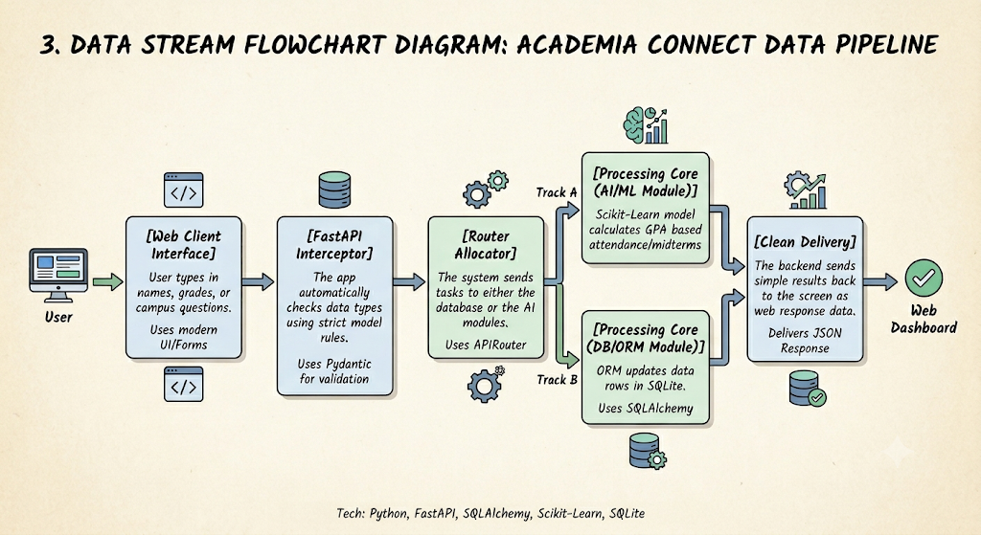
4. TECHNOLOGY STACK SPECIFICATIONS
- Core Framework: Python and FastAPI are used for fast response speeds and automated API test screens.
- Database Layer: SQLite and SQLAlchemy 2.0 handle data profiles using clean, safe object structures.
- Prediction Engine: Scikit-Learn and NumPy run data math pipelines to estimate student grade boundaries.
5. CORE FEATURES BREAKDOWN
- Record Manager: The system tracks rows with automatic IDs, names, attendance scores, and test marks.
- Lifecycle Control: Helper tools open, isolate, and auto-close database connections for every web request.
- Smart Predictor: A linear regression model learns from old data trends to forecast a student's standing.
- Boundary Caps: The code uses mathematical array clipping to keep grade outputs strictly between 0.0 and 4.0.
- Policy Chatbot: The assistant uses text matching logic to check questions against official college rules.
- Knowledge Bounds: The bot gives immediate text answers for library timings, grade scales, and attendance limits.
6. PRODUCTION SAFETY AND EXCEPTION HANDLING
- Server Error Fix: Separating internal database models from web input models completely stops unexpected 500 server crashes.
- Hack Protection: Using built-in database parameters automatically blocks harmful query text injection exploits.
- Auto Alignment: The app scans for data tables on startup and builds them automatically if the file is fresh or empty.
7. PROJECT OUTCOMES AND GROWTH ANALYSIS
- Code Separation: Learned how to split full-stack logic into separate routers, data tables, and AI scripts.
- Professional Habits: Mastered the practice of using strict type rules, data verification blocks, and clean comments.
- Team Coordination: Linked tech development steps with organization skills gained while managing volunteer teams as an NSS representative.
- Clear Communication: Used student leadership experience to design chatbot responses that answer high-priority, real-world campus problems simply.

